Creating Import/Export Plugins

Written By: | RAB | Creation Date: | 1/14/2009
Reviewed By: |  | Last Revised:
Project: | PGSuper | WI # | <<#>>
 |  | Version | 1.0 - Draft

Purpose
The purpose of this document is help developers understand how to create Import/Export Plug-ins for PGSuper.

General
It is a common task to import and export data from applications. PGSuper provides specialized interfaces for plug in components that can import and export application data. Import/Export plug-ins can be created by anyone for any purpose. The interfaces are licensed with the Alternate Route Library Open Source License and it is permissible for third parties to write proprietary plug-ins that supports theses interfaces.

Some ideas for importers include:
- Read input from the AASHTO BridgeWare database
- Read input files for different precast girder programs such as TxDOT PSTR14, or Wyoming BRASS
- Read geometry information from a LandXML data source or other roadway modeling program

Some ideas for exporters include:
- Write agency specific data to a text file
- Write structural analysis results to an Excel file
- Write input files for another application
- Store input in the AASHTO BridgeWare database

The uses of importers and exporters are virtually unlimited.

PGSuper Importers
A PGSuper Importer can be either a Project Importer or a Data Importer. A project importer imports an entire PGSuper project. That is, it creates a new PGSuper project and imports all data necessary for the project from the external source.

A data importer imports select pieces of information into the current project file. For example, a data import may import an alignment definition from a LandXML file.

Interfaces
Importer components must implement the IPGSuperImporter interface. Exporter components must implement the IPGSuperExporter interface. Importers and exporters must be registered with the PGSuperIEPlugin component category. These interfaces, their identifiers (IIDs) and the component category identifier (CATID) are defined in PGSuperIEPlugin.h.

enum ImporterType
{
impProject = 1, // imports entire PGSuper projects (creates a new document)
impData = 2 // imports data into the current document
};

IPGSuperImporter

HRESULT GetType(ImporterType* pType);
Returns the import type enum value.
Returns S_OK if successful

HRESULT GetMenuText(BSTR** ppbstrText);
Gets the text to be displayed on the File | Import menu
Returns S_OK if successful

HRESULT Import(IBroker* pBroker);
This function is called by PGSuper when the user selects the import command for this component from the File | Import menu. Use the IBroker interface to request the other interfaces available in PGSuper (refer to documentation on the Agent/Broker architecture for more information)
Returns S_OK if successful

IPGSuperExporter

HRESULT GetMenuText(BSTR** ppbstrText);
Gets the text to be displayed on the File | Export menu
Returns S_OK if successful

HRESULT Export(IBroker* pBroker);
This function is called by PGSuper when the user selects the export command for this component from the File | Export menu. Use the IBroker interface to request the other interfaces available in PGSuper (refer to documentation on the Agent/Broker architecture for more information)
Returns S_OK if successful

Procedure
Follow these basic steps to create a new PGSuper Import/Export Plugin. This procedure highlights the specific compiler settings; however they may need to be slightly altered for your particular situation.
- Create a new ATL COM Dynamic Link Library program. Add MFC support if desired (this is recommended if you need any kind of user interface)
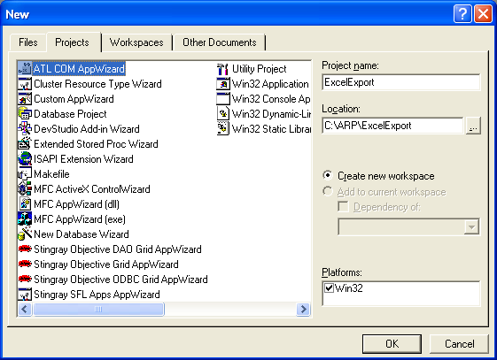
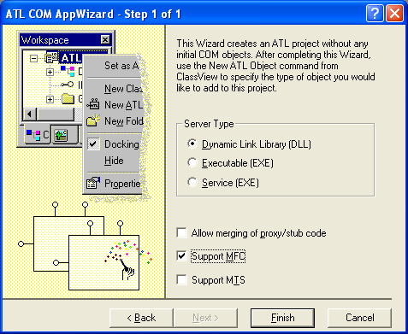
- Create a new ATL object. Use the Simple Object from the Objects category. 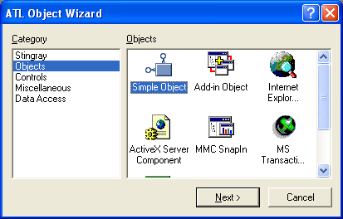
- Provide the names for the object and, on the Attributes tab, choose Custom interface
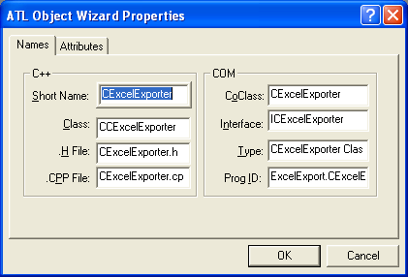
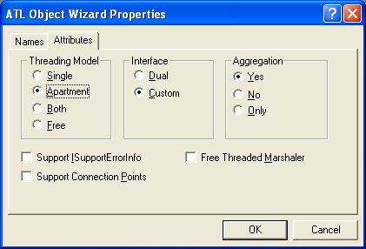
- Repeat the previous step for the exporter if desired
- Open the IDL file and
  - Delete the interface stub that was generated for you
  - Add import “PGSuperIEPlugin.idl”;
  - Change the default interface on the Importer COM object to IPGSuperImporter and to IPGSuperExporter on the Exporter COM object.
import "oaidl.idl";
import "ocidl.idl";
import "PGSuperIEPlugin.idl";
[
uuid(10AC6E6E-FC9F-4263-961C-D0284C5700BE),
version(1.0),
helpstring("ExcelExport 1.0 Type Library")
]
library ExcelExportLib
{
importlib("stdole32.tlb");
importlib("stdole2.tlb");
[
uuid(5EF2F193-5B3F-48C7-A812-8CA8EBB11781),
helpstring("ExcelExporter Class")
]
coclass ExcelExporter
{
[default] interface IPGSuperExporter;
};
};
- Configure the Project Settings
  - Open project settings dialog, select All Configurations and select the C\C++ tab
  - Set the Category to Preprocessor. Add ARP\PGSuper\Include\Plugin to the Additional include directories field
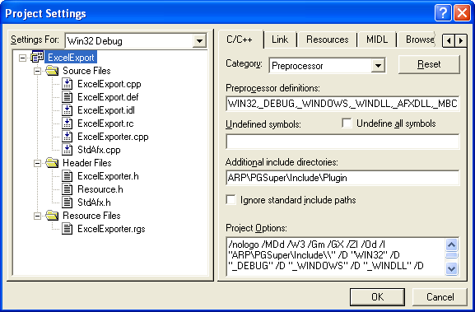
  - Select the Link tab. Set the Category to Input. Add ARP\Lib;ARP\PGSuper\Lib to the Additional library path field
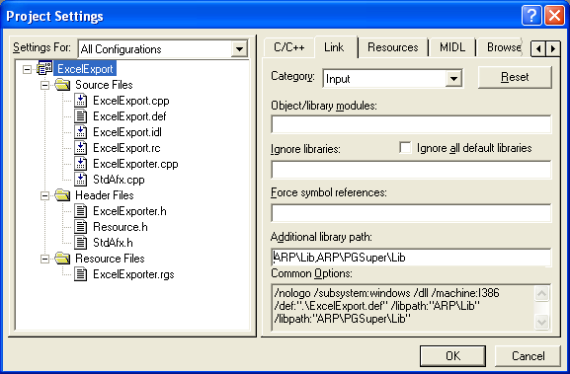
  - Select the MIDL tab. Add ARP\PGSuper\Include to the Additional include directories field
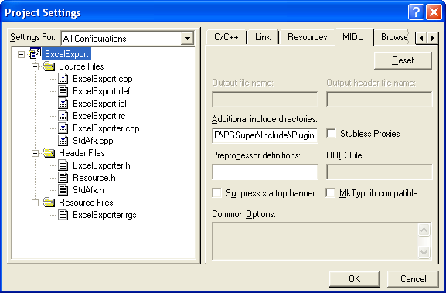
  - Press OK to apply the project settings
- Register the component with the PGSuper IE Plugin Component Category
  - Implement DllRegisterServer
STDAPI DllRegisterServer(void)
{
// registers object, typelib and all interfaces in
// typelib
// THIS MUST OCCUR BEFORE COMPONENT CATEGORY REGISTRATION
HRESULT hr = _Module.RegisterServer(FALSE);
if ( FAILED(hr) )
return hr;
//
// Component Category Registration
//
// register with the PGSuperIEPlugin component category
hr = S_OK;
CComPtr<ICatRegister> pICatReg = NULL;
hr = ::CoCreateInstance( CLSID_StdComponentCategoriesMgr,
NULL,
CLSCTX_ALL,
IID_ICatRegister,
(void**)&pICatReg );
if ( FAILED(hr) )
return hr;
const int nID = 1;
CATID ID[nID];
ID[0] = CATID_PGSuperIEPlugin;
// register the component objects with the component category
hr = pICatReg->RegisterClassImplCategories( CLSID_ExcelExporter, 1, ID );
if ( FAILED(hr) )
return hr;
return S_OK;
}
  - Implement DllUnregisterServer
STDAPI DllUnregisterServer(void)
{
// unregister with the PGSuperIEPlugin component category
HRESULT hr = S_OK;
CComPtr<ICatRegister> pICatReg = NULL;
hr = ::CoCreateInstance( CLSID_StdComponentCategoriesMgr,
NULL,
CLSCTX_ALL,
IID_ICatRegister,
(void**)&pICatReg );
if ( FAILED(hr) )
return hr;
const int nID = 1;
CATID ID[nID];
ID[0] = CATID_PGSuperIEPlugin;
hr = pICatReg->UnRegisterClassImplCategories( CLSID_ExcelExporter, 1, ID );
if ( FAILED(hr) )
return hr;
_Module.UnregisterServer();
return S_OK;
}

- Implement the IPGSuperExporter interface
  - Open the header file for your PGSuper Exporter
  - Replace the interface generated by the COM wizard with IPGSuperImporter
  - Add the function declarations for the IPGSuperImporter interface
class ATL_NO_VTABLE CExcelExporter :
public CComObjectRootEx<CComSingleThreadModel>,
public CComCoClass<CExcelExporter, &CLSID_ExcelExporter>,
public IPGSuperExporter
{
public:
CExcelExporter()
{
}
DECLARE_REGISTRY_RESOURCEID(IDR_EXCELEXPORTER)
DECLARE_PROTECT_FINAL_CONSTRUCT()
BEGIN_COM_MAP(CExcelExporter)
COM_INTERFACE_ENTRY(IPGSuperExporter)
END_COM_MAP()
// IPGSuperImporter
public:
STDMETHOD(GetMenuText)(/*[out,retval]*/BSTR* bstrText);
STDMETHOD(Export)(/*[in]*/IBroker* pBroker);
};
  - Add the function definitions
// IPGSuperImporter
STDMETHODIMP CExcelExporter::GetMenuText(BSTR* bstrText)
{
*bstrText = CComBSTR("THIS TEXT GOES ON THE FILE | EXPORT MENU");
return S_OK;
}
STDMETHODIMP CExcelExporter::Export(IBroker* pBroker)
{
// Do something great when this function gets called
return S_OK;
}
- Repeat for the Importer

